Dennis Adiwinata Irwan Soeroso

A11.2021.13225

Praktikum Minggu 4

1. Form1-login.html

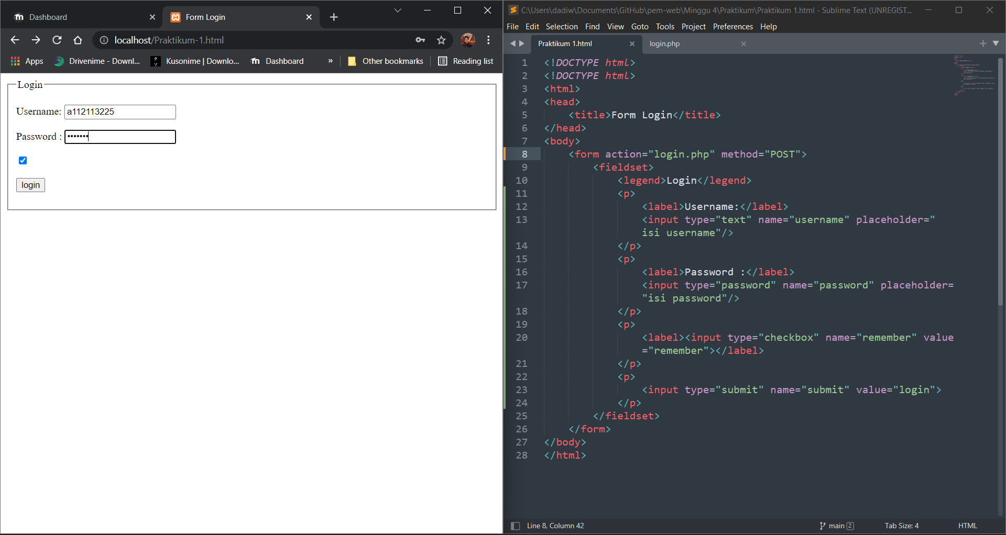

1. Form2-contact.html

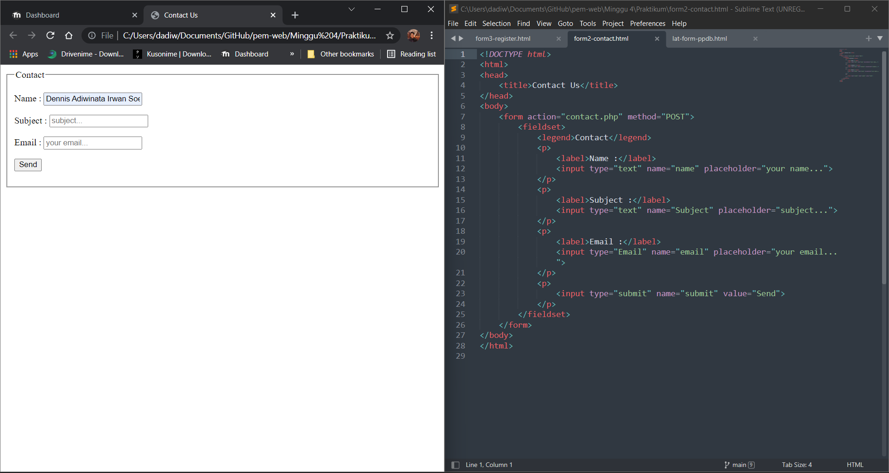

1. Form3-register.html

